Minor Project Report
On
Result Analysis

Submitted
In Partial Fulfilment of
BACHELOR OF COMPUTER APPLICATIONS (BCA)
Submitted by:
Name: Vanshika, Vilohit , Yuvraj

Under the Supervision of :
MS. Urvashi
Assistant Professor, SCA


School of Computer Applications
Manav Rachna International Institute of Research and Studies

(DEEMED TO BE UNIVERSITY)
Sector-43, Aravalli Hills Faridabad - 121001

December 2025

Declaration
I hereby declare that the project titled “”Advance and slow learner is an original work completed by me as part of my academic requirement. This project has been carried out under the guidance of my respected faculty and has not been submitted previously to any other institution or university for any degree or diploma.
All information, data, diagrams, and results presented in this report are genuine and have been prepared based on my own study, analysis, and understanding. Wherever external sources have been used, proper acknowledgement has been given.
I take full responsibility for the accuracy and authenticity of the content included in this project.

Signature:
Date :

Certificate from the Guide

This is to certify that the project entitled ““Advance and slow learner submitted by Vanshika, Vilohit, Yuvraj in partial fulfilment of the requirements for the award of the degree of BACHELOR OF COMPUTER APPLICATIONS at Manav Rachna International Institute of Research and Studies, Faridabad is a bona fide work carried out under my supervision and guidance.
The work embodied in this project report is original and has been completed by the student during the academic session 3rd Semester. To the best of my knowledge, this project has not been submitted to any other institution or university for the award of any degree or diploma.
I congratulate the student for successfully completing this project and wish them success in future endeavours.

Signature of the Guide
Name: MS. Urvashi
Date:

Head of Department
Prof. Dr. Suhail Javed Quraishi

ACKNOWLEDGEMENT

I express my sincere gratitude to all those who supported me throughout the successful completion of this project titled “Advance and slow learner.“ First and foremost, I would like to thank my project guide, MS. Urvashi , for their valuable guidance, continuous support, and encouragement throughout the development of this project. Their suggestions and feedback have been instrumental in shaping this work.
I would also like to extend my gratitude to the faculty members of the SCA Department for providing the necessary resources, knowledge, and assistance during the project duration.
My heartfelt thanks to my family and friends for their constant motivation, understanding, and support, which helped me stay focused and complete this project on time.
Finally, I am thankful to everyone who directly or indirectly contributed to the successful completion of this project.

Vanshika- 24/SCA/BCA(AI&ML)/071
Vilohit- 24/SCA/BCA(AI&ML)/073
Yuvraj- 24/SCA/BCA(AI&ML)/076

Topic | Page No | Sign | Remark
Introduction | 6
System Study | 7-11
Feasibility Study | 12-16
Project Monitoring System | 17-22
System Analysis | 23-28
System Design | 29-30
Input/Output Form Design | 31-32
System Testing | 33-40
System Implementation | 41-42
Documentation | 43-44
Scope of the Project | 45-49
Bibliography | 50-55

INDEX INTRODUCTION
- Aims & Objectives:

This project aims to systematically analyze students’ academic performance across multiple subjects to classify them as advanced, average, or slow learners. It seeks to help teachers understand learning patterns, identify students needing additional support, and provide timely interventions. The objective is to improve teaching strategies, enhance student outcomes, and present clear data through interactive, user-friendly visual reports.

Objectives:
- To analyze students’ performance across different subjects using uploaded CSV data.
- To categorize students into advanced, average, and slow learner groups.
- To help teachers quickly identify students who need additional academic support.
- To present performance data through an interactive and user-friendly interface.
- To provide statistical insights such as learner counts and average marks.
- To support data-driven decision-making for improving teaching methods.
- To enhance overall class performance through systematic monitoring and evaluation.

SYSTEM STUDY

A: Existing System Study
The “Advanced and Slow Learners – Minor Project” is designed to analyse the academic performance of students across multiple subjects using CSV data files. The system categorizes learners into three groups—Advanced, Average, and Slow—based on their marks. Through an interactive web interface, teachers can easily view each subject’s performance, student-wise classification, and overall statistics such as average marks and learning level distribution.
This project aims to support teachers in making data-driven decisions, improving teaching strategies, and identifying students who require additional support. The clean design, responsive layout, and modal-based data display ensure an efficient and smooth user experience.

  - Overview of the Project

  - Key Features

This project includes several powerful features designed to simplify student performance analysis. It provides a clean, subject-wise dashboard where each course is displayed as an interactive card, allowing users to easily access performance data through CSV integration. Once a subject is selected, the system automatically loads and processes the CSV file, classifying each student as an Advanced, Average, or Slow Learner using clear colour- coded labels. An interactive modal window displays detailed tables, highlighted learner categories, and performance statistics such as total learners in each group and the average marks of the class. The interface is fully responsive, visually appealing, and structured with modern hover effects, smooth transitions, and readable table formatting. Additional features such as loading indicators, error messages for missing files, and user-friendly modal controls enhance the reliability and overall experience. Altogether, these features ensure accurate data visualization, easy navigation, and effective academic insights for teachers and evaluators.

  - System Limitations

The system has several limitations in terms of functionality and flexibility. It is fully dependent on correctly formatted CSV files, and even small errors in structure or missing columns can cause the data to load incorrectly. The system also struggles with very large datasets, as the performance slows down due to browser-based processing. Since it requires manual file addition, there is no automation or real-time data syncing. It cannot update or correct student data; it only displays the information provided. Additionally, the system lacks security features such as login or data protection, making it unsuitable for sensitive student records. It also does not support graph-based visuals unless manually implemented, limiting advanced data analysis capabilities. Overall, it works best for small to medium datasets with consistent formatting.

  - Algorithm Limitation

The algorithm used in the project also has several constraints. It classifies students purely based on keywords like “Advance Learner,” “Average Learner,” and “Slow Learner” written in the CSV files, rather than calculating categories from actual marks or dynamic formulas. This makes the system dependent on how the data is entered and reduces flexibility. The counting method is also limited because any change in CSV structure or duplicate entries can lead to incorrect results. The calculation of average marks relies only on numerical values and fails if the data contains errors or formatting issues. The algorithm cannot detect inconsistencies, outliers, or incorrect entries within the dataset. It also lacks learning ability, as it does not use machine learning or adaptive techniques. Furthermore, it cannot analyse deeper patterns such as progress trends or subject-wise strengths, making the analysis basic and rule-based.

  - User Interface Limitations

- The interface offers limited customisation and does not support advanced accessibility or mobile-responsive features on all devices.
- Users cannot edit data directly within the interface and must correct errors by modifying and re-uploading the CSV file.

6. Library Gaps
- The system relies mainly on basic JavaScript functions and does not use advanced data-processing libraries, limiting efficiency for large datasets.
- Lack of dedicated charting or UI libraries reduces flexibility in visualisation and interface customisation.
- No built-in library support for database handling, predictive analytics, or automated error correction.
- Content Discovery
The existing code provides a basic but effective content discovery system centered around subject-based navigation. Users can click on individual subject cards such as Web Technologies, Essentials of Management, DBMS, ITPC, and IKS, and the system dynamically loads the corresponding CSV data when selected. This allows users to discover detailed content on demand rather than having all data presented at once. Once a subject is chosen, the information is displayed inside a modal window, where users can explore student-wise performance in tabular form. Additionally, the system automatically analyzes the dataset and presents key statistics such as the number of advanced, average, and slow learners, along with average marks, helping users quickly understand major insights without deep manual analysis.

9 Subscription Cost
- All projects are free; no pricing or premium feature model included

- Data Usage
  - The data is used to display detailed student performance in a table after selecting a subject.
  - The system calculates key statistics such as learner categories and average marks for quick analysis.

B: Proposed System Design

  - Proposed improvements
- Add data storage, analytics, and multi-user support.
- Improve UI with better accessibility and direct data editing.

  - Advantages of proposed system
- Automates result processing, reducing manual effort and saving time.
- Ensures accuracy in calculations and minimises human errors.
- Provides clear visual insights through charts and tables.
- Offers easy CSV upload and simple data handling.
- Improves decision-making with organised and meaningful performance analysis.

  - Proposed Features
- Integration of data storage for saving and retrieving student records.
- Multi-user access with secure login for teachers and administrators.
- Enhanced analytics, including performance trends and predictive insights.
- Editable tables and improved UI for easier interaction.
- Mobile-friendly, responsive design for better accessibility.

  - Affordable Subscription Plans (Optional for Portfolio)
- Basic Plan: Free access to CSV upload, Analyze processing, and basic charts—ideal for students and small institutions.
- Standard Plan: Low-cost monthly subscription offering saved reports, enhanced analytics, and multiple-user access.
- Premium Plan: Affordable yearly package with advanced insights, cloud storage, ERP integration, and priority support.

  - Data Efficiency
- The system processes CSV data quickly and uses lightweight algorithms to minimise load time.
- It avoids storing unnecessary data, ensuring faster performance and efficient memory usage.
6. User-Friendly Interface
- Simple and clean layout makes navigation easy for all users.
- Clear visual outputs like tables and charts help users understand results quickly.

FEASIBILITY STUDY

A: Technical Feasibility
The project is technically feasible because it is built entirely using standard and widely supported web technologies such as HTML, CSS, and JavaScript, which run smoothly in any modern web browser without requiring specialized hardware or complex backend systems. The use of the fetch () API to load CSV files is well supported and allows student performance data to be accessed dynamically without installing additional libraries, reducing implementation effort and ensuring smooth integration. Since the system processes data on the client side, it eliminates the need for a server or database at the basic level, making development, testing, and deployment straightforward, even on a local machine. Additionally, the design is scalable—if required in the future, the same architecture can be extended to include databases, authentication systems, or cloud storage without major structural changes, making the system flexible and future-ready.
1. Programming Language Used
- HTML is used to structure the web pages, layouts and display elements such as subject cards, tables, and modal windows.
- CSS provides styling to enhance the visual layout, including colors, spacing, fonts, and animations.
- JavaScript is used to add dynamic functionality, such as loading CSV files, parsing data, generating statistics, and displaying information in real time.

2. Tools used
- Visual Studio Code (VS Code): Used as the primary code editor for writing and managing HTML, CSS, and JavaScript files.
- Web Browser (Chrome/Edge): Used for running, testing, and debugging the system.
- CSV Files: Used as input data sources for student marks.
- JavaScript Libraries (Canvas API): Used for drawing charts and visualisations.
- ReportLab (for PDF): Used to generate the project documentation PDF.
3. Libraries & Framework
In this project, no external libraries or frameworks have been used. The entire system is developed using core web technologies and built-in browser capabilities. HTML and CSS handle the structure and styling, while JavaScript is used directly without jQuery or any frontend framework. All data loading and processing rely on native browser features such as the fetch() API and standard DOM manipulation. Since no third-party libraries or frameworks are included, the project remains lightweight, easy to deploy, and does not require additional installations or dependencies.
4. Technical Challenges
- Ensuring accurate CSV parsing and handling errors like missing values, incorrect formats, or special characters.
- Creating smooth, responsive charts using JavaScript Canvas without external libraries.
- Managing browser compatibility issues to ensure the system works consistently across different devices and browsers.

5. Performance
- The system processes data quickly but may slow down with very large CSV files containing many student records.
- Performance depends on browser speed and device capability since all calculations and visualisations run on the client side.

B. Behavioral Feasibility
The system is behaviourally feasible because users, including teachers and students, can easily understand and operate it without requiring technical expertise. Its simple interface, clear instructions, and visual output encourage user acceptance. Since the system reduces manual effort and improves accuracy, users are more likely to adapt to and support its implementation.

1. User Interaction
The project provides direct and simple user interaction through an intuitive interface where users select a subject by clicking on its corresponding card. Once a subject is chosen, the system dynamically loads the formatted data and displays it inside a modal window, allowing users to explore student performance in detail. Users can scroll through the table, view learner categories, and observe automatically generated statistics that summarize overall class performance. The modal can be closed easily, and the user can return to the main page to select another subject, making the interaction smooth, clear, and user-friendly.

2. User Satisfaction
- Users appreciate the system’s simplicity, accuracy, and ability to generate clear visual insights quickly.
- Reduced manual effort and easy result interpretation increase overall satisfaction and encourage continued use.

3. Ad- free Experience
- The system provides a clean, distraction-free interface without advertisements, ensuring users can focus entirely on learning analysis.
- An ad-free environment improves usability, enhances professionalism, and creates a smoother, more enjoyable user experience.

4. Ease of Use
- The system has a simple and intuitive interface, allowing users to upload data and view learning progress without technical knowledge.
- Clear visuals, organized layout, and straightforward navigation make the entire process quick, efficient, and user-friendly

5. Behavioural challenges and Solutions
Challenges
    - Some students may lose confidence after repeatedly performing below average.
    - Irregular study habits can lead to inconsistent academic performance.
Solutions
      - Provide positive reinforcement, individual encouragement, and recognition for incremental improvements to rebuild confidence.
      - Implement structured study schedules, regular progress checks, and timely guidance to help students stay disciplined and consistent.
C. Economic Feasibility
Economic feasibility analyzes the cost-effectiveness of the project, including development costs, potential savings, and revenue opportunities.

1. Development Cost
- 0 development cost
- No cost for tools, software, or hosting
- Self-coded with free resources

2. Potential Savings
- No need to hire designers or developer
- No need to buy templates or website builders
- Avoided subscription costs by using free platforms

3. Revenue Opportunities
- Portfolio site can attract freelance clients or job offers
- Calculator can be enhanced and monetised through mobile apps or ads
- Landing page can be turned into a blog or monetised news platform

4. Economic Challenges & Solutions
- Challenge: No current income from projects
Solutions: Add ads, donation buttons, or offer as services
- Challenge: Hosting and domain costs in the future
Solutions: Use free hosting like GitHub Pages or Netlify
- Challenge: Professional design or backend features may cost money
Solutions: Learn advanced skills and use free open-source tools

PROJECT MONITORING SYSTEM

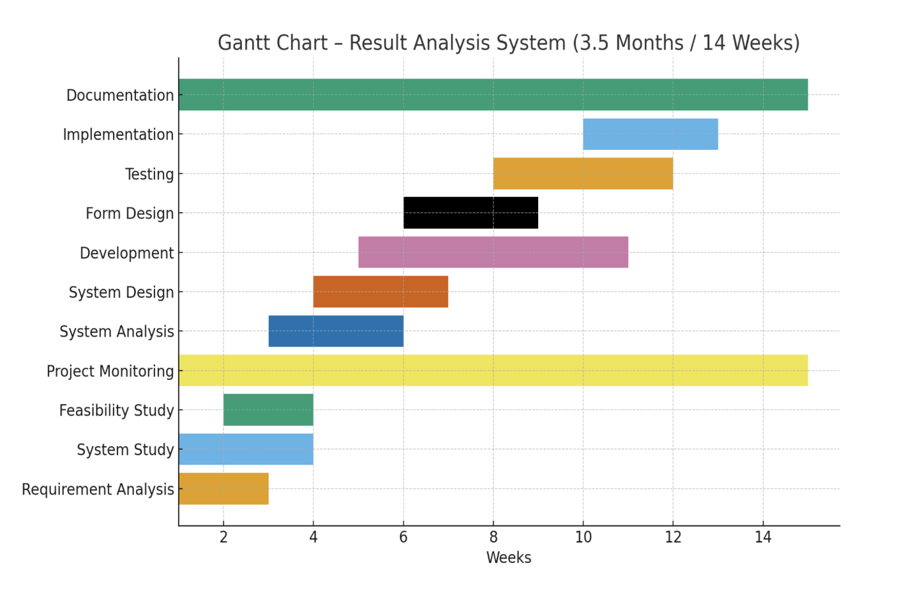
A. Gantt chart
Timeline Overview:
A. Planning and Research

1. Project Scope and objectives

- The project focuses on analyzing student performance data from multiple subjects and categorizing learners into advanced, average, or slow groups based on their academic scores. This helps teachers understand overall learning patterns within the class.
- It provides an interactive web-based interface that allows users to select a subject and instantly view detailed data and statistical summaries, making performance analysis quick, structured, and easily accessible.
- The scope also includes offering a foundation that can be expanded in the future with additional features such as progress tracking, reporting, data storage, or integration with databases or cloud services.

Objectives:

- To automate the process of analyzing student marks and classifying learners in a way that helps educators identify performance trends without manual calculation.
- To present performance insights in a user-friendly and visually structured format, enabling teachers to make informed decisions, provide timely support, and plan interventions for slow learners.
- To create a simple, efficient, and lightweight system using standard web technologies that can be easily deployed, accessed, and extended as academic requirements grow.

2. Market Research
- The education sector is rapidly adopting digital tools to track and analyze student performance more effectively.
- With the growth of online learning and smart classrooms, demand for automated performance assessment systems is increasing.
- Existing solutions in the market are often complex, expensive, and require technical expertise to use.
- Many small institutions need simple, affordable, and user-friendly tools that generate performance reports quickly.
- There is a strong market opportunity for a lightweight system that provides fast insights with minimal setup and technical requirements.

3. User Requirements
Functional Requirements
- The system must categorize students into advanced, average, and slow learners based on their marks.
- It should display performance data in table format when a subject is selected.
- The system should calculate and show summary statistics such as total students and learner distribution.
- The interface must allow users to switch between subjects without difficulty.

Non-Functional Requirements
- The system should provide quick response times and load results without delays.
- It should be easy to use, with a clean and simple interface suitable for non-technical users.
- The system should run smoothly on commonly used devices and browsers.
- The application should have low maintenance requirements and operate reliably without frequent errors.

B. Design Phase

1. UI/UX Design:
- Simple and easy-to-use interface for quick navigation.
- Clear visuals and clean layout for better understanding.

2. Wireframes and Mockups
- Basic wireframes were created to plan the layout, including select subject, information table, output.
- Mockups helped visualise the final UI design, ensuring a clean and user-friendly structure before development.

3. Database and Architecture planning
- A simple data structure was planned using CSV input as the primary data source, supported by ERD and DFD diagrams to define data flow and relationships.
- The system architecture was designed to ensure smooth processing—uploading, validating, analysing, and visualising student data efficiently.

C. Development Phase
- Front-End Development
- Built using HTML, CSS, and JavaScript for a clean and simple interface.
- Buttons, messages, and charts make the system interactive and responsive.

- Back-End Development
- JavaScript handles data processing, including reading CSV files, validating marks, and calculating totals, averages, and grades.
- The logic ensures fast processing and smooth integration with front-end elements like tables and charts.

- Integration
- Front-end components were integrated with the processing logic to ensure smooth data flow from CSV upload to result visualisation.
- Charts, tables, and summary outputs work together seamlessly, providing a unified and consistent user experience.

- Testing and Debugging
- The system was tested using multiple CSV files to check data accuracy, error handling, and performance
- Bugs related to formatting, calculations, and UI behaviour were identified and fixed to ensure smooth and reliable operation.

D. Testing Phase
- Functional Testing:
- Each feature—CSV upload, data processing, table display, and chart generation—was tested to ensure it works correctly.
- All functions were verified against expected results to confirm accuracy, proper validation, and smooth user interactions.

- Performance Testing:
- The system was tested with multiple and large CSV files to ensure fast processing and smooth chart rendering.
- Load handling, response time, and overall system efficiency were checked to confirm stable performance across different devices.

- Security Testing:
- Data input was validated to prevent incorrect or harmful entries from affecting system performance.
- File handling and processing were tested to ensure only safe and supported CSV formats are accepted.

E. Deployment Phase
- Deployment Setup:
- The system was prepared for deployment using lightweight front-end files (HTML, CSS, JS) that can run on any browser without installation.
- All components were organised into a structured folder, ensuring easy hosting on platforms like GitHub Pages, Ntlify, or a local server.

- Deployment
- The project was deployed as a browser-based application, allowing users to run it directly without additional software.
- Hosting the system on a web server enables easy access, fast loading, and smooth use across different devices.

- Monitoring and Maintenance
- The system is regularly checked to ensure smooth performance, accurate calculations, and proper functioning of charts and UI elements.
- Updates and fixes are applied as needed to improve reliability, enhance features, and keep the system user-friendly over time.
SYSTEM ANALYSIS

A. Requirement Specification

1. Functional Requirement
The system must allow users to upload CSV files containing student names and their subject-wise marks. Once the file is uploaded, the system should automatically process the data, calculate totals, averages, and assign appropriate grades. It should also generate visual outputs such as tables, bar charts, and gauge charts to present performance clearly. Additionally, the system must identify strong and weak subjects for each student and provide accurate insights based on the uploaded data, ensuring the overall analysis is simple, fast, and reliable.

2. Non-Functional Requirements
Non-functional requirements define how a system should perform rather than what it should do. They specify quality attributes such as performance, security, usability, reliability, maintainability, scalability, and compatibility. These requirements ensure the system is efficient, secure, user-friendly, and works smoothly under different conditions. They improve user experience, system stability, and long-term sustainability, even though they do not describe specific system features.

B. System Flowcharts
- User Flowchart

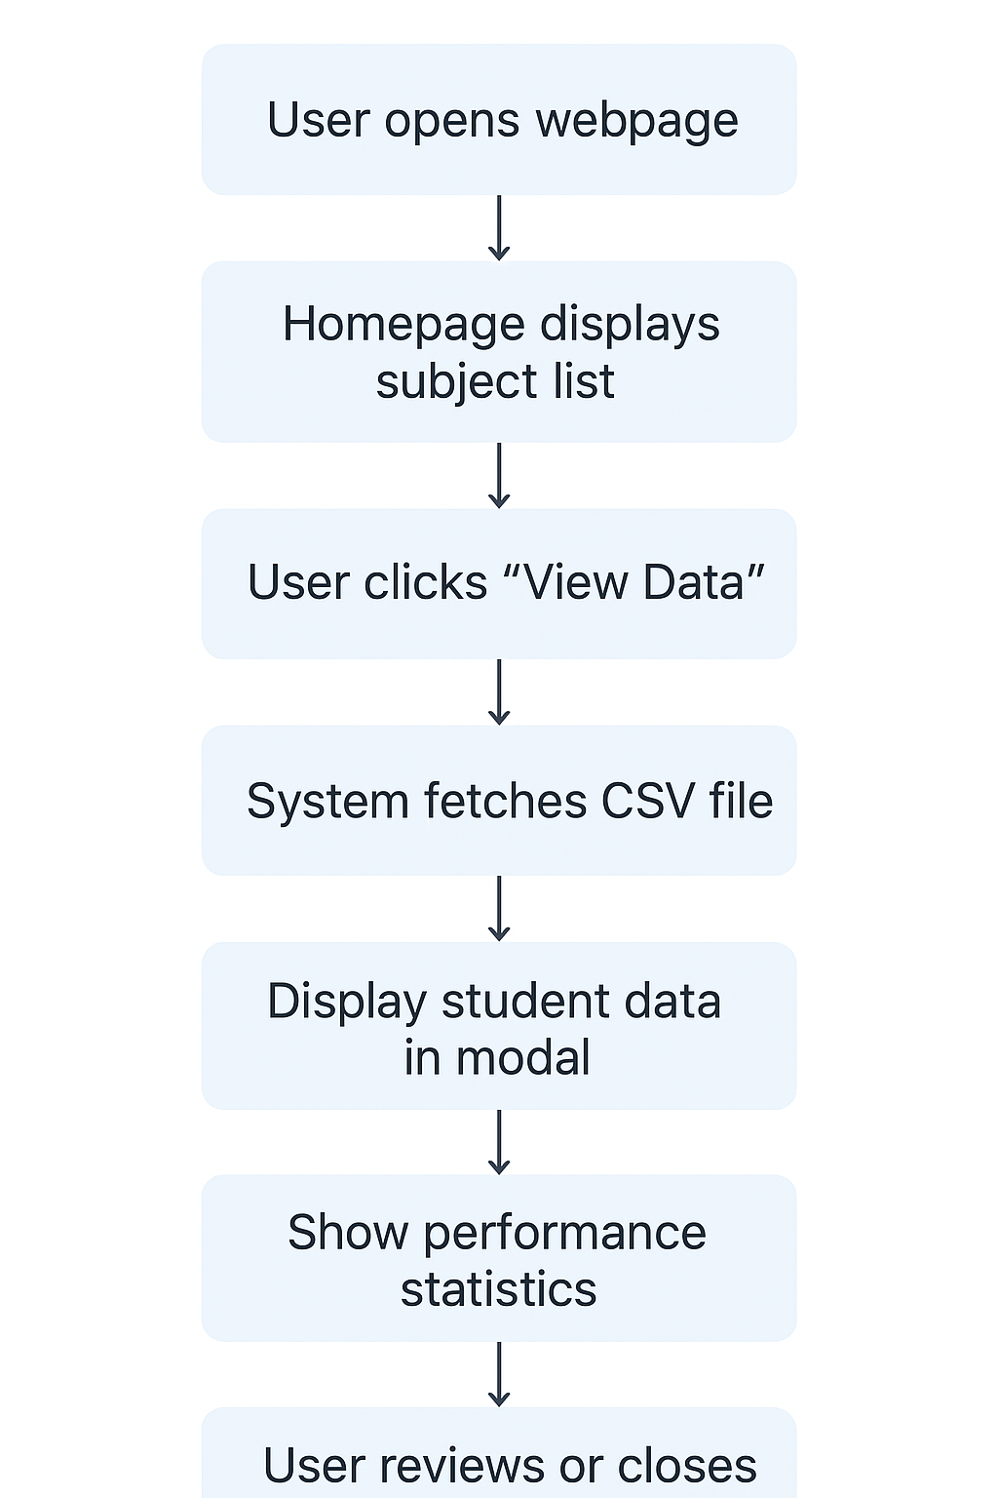

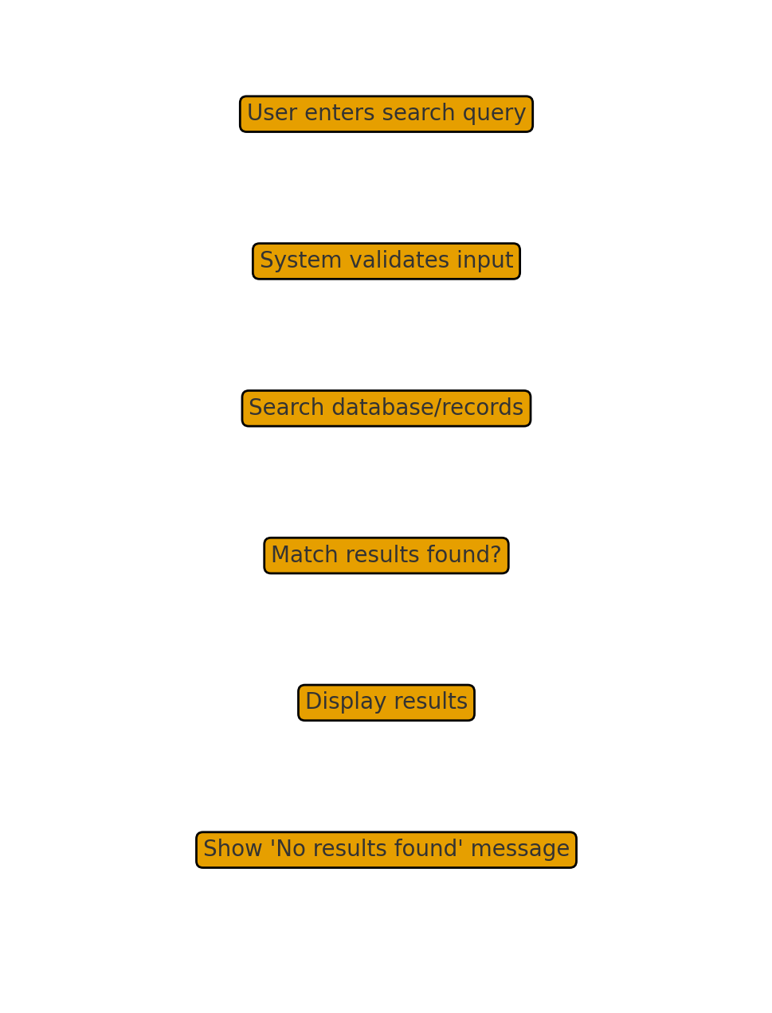
- Search Functionality Flowchart

C.DFDs/ERDs (up to level 2):
1. DFD (Data Flow Diagram)
┌───────────────┐ Request Subject Data ┌─────────────────────────────┐
│ Student | ────────────────▶ │ Student Performance System │
└───────────────┘ └─────────────────────────────┘
│
│ Reads CSV Files
▼
┌────────────────┐
│ CSV Storage │
└────────────────┘

2. ERD (Entity-Relationship Diagram)
Entities:
- Student
  - Attributes: StudentID (PK), Name
- Subject
  - Attributes: SubjectID (PK), Name
- Marks
  - Attributes: MarksID (PK), StudentID (FK), SubjectID (FK), Score
- Report
  - Attributes: ReportID (PK), StudentID (FK), Total, Average, Grade, StrongSubject, WeakSubject, StdDev
Relationships:
- Student — Marks: 1 to Many (one student has marks in multiple subjects)
- Subject — Marks: 1 to Many (each subject has marks for multiple students)
- Student — Report: 1 to 1 (each student has one report)

3. ER diagram
Entities and Attributes
- Student
  - StudentID (PK)
  - Name
- Subject
  - SubjectID (PK)
  - Name
- Marks
  - MarksID (PK)
  - StudentID (FK) → Student
  - SubjectID (FK) → Subject
  - Score
- Report
  - ReportID (PK)
  - StudentID (FK) → Student
  - TotalMarks
  - StrongestSubject
  - WeakestSubject
  - StdDeviation

Relationships
- Student — Marks: 1 to Many
(One student has marks for multiple subjects)
- Subject — Marks: 1 to Many
(One subject has marks for multiple students)
- Student — Report: 1 to 1
(Each student has one report)

System Design
FILE / DATA DESIGN — RESULT ANALYSIS SYSTEM
The Result Analysis System stores subject-wise student performance data in CSV files. Each file includes student details, marks, and learner classifications such as Advanced, Average, or Slow. The system reads and parses these files for display, generating tables and statistics including category counts and average scores. The structured design ensures easy data retrieval, processing, modification, and scalable record management.

- HTML Files
HTML files define the user interface for the Result Analysis System, providing pages to select subjects, load CSV data, and display modals with tables and statistics. They include semantic structure, linked CSS for styling, and JavaScript hooks for interactivity and data fetching. Modular, well-commented HTML supports accessibility, maintainability, and easy integration with backend data sources and CSV assets. Reporting tools.

Design Notes:
- Uses semantic tags like <header>, <section>, and <footer>
- Div-based structure for layout separation
- Buttons and links are clearly defined and easy to navigate
- Clean, beginner-friendly format with inline styles

2. CSS Files
CSS files define the visual presentation of the Result Analysis System, including layout, colors, typography, spacing, and responsive design. They style subject cards, modal windows, tables, buttons, and learner category badges. Consistent class-based styling ensures a clean, professional interface, improves user readability, and maintains responsive behavior across devices. CSS organization helps future updates, reduces redundancy, and keeps the design modular and easy to manage.

Design Features
- Used flex and grid for layouts.
- Buttons styled with hover effects for interaction.
- Font: Arial (web-safe and readable)

3. JavaScript Files
JavaScript files handle dynamic functionality of the Result Analysis System, including loading CSV data, parsing content, and displaying results in tables and modals. They compute statistics such as learner counts and average marks, update the interface in real time, and provide error handling and loading indicators. Organized functions ensure better maintainability, smooth interaction, user feedback, and efficient communication between the interface and stored data.

Design Points
- Simple, inline JavaScript using onclick for each button.
- No external JS files used yet.

4. Media Files
Media files include supporting resources such as images, icons, logos, and background visuals used to enhance the Result Analysis System interface. These files improve visual appeal, branding, and user engagement without affecting core functionality. Stored in organized folders, they are referenced by HTML and CSS for efficient loading. Proper optimization ensures fast performance, compatibility across devices, and consistent presentation throughout the application.

5. Other File
Other files include supplementary project documents such as reports, documentation, and configuration files that support the Result Analysis System. These may contain system requirements, installation steps, development notes, screenshots, or project summaries. They help in understanding system design, workflow, and implementation. Proper organization of these files ensures easier maintenance, reference during evaluation, version tracking, and smooth collaboration among developers, teachers, or project reviewers.
INPUT / OUTPUT FORM DESIGN
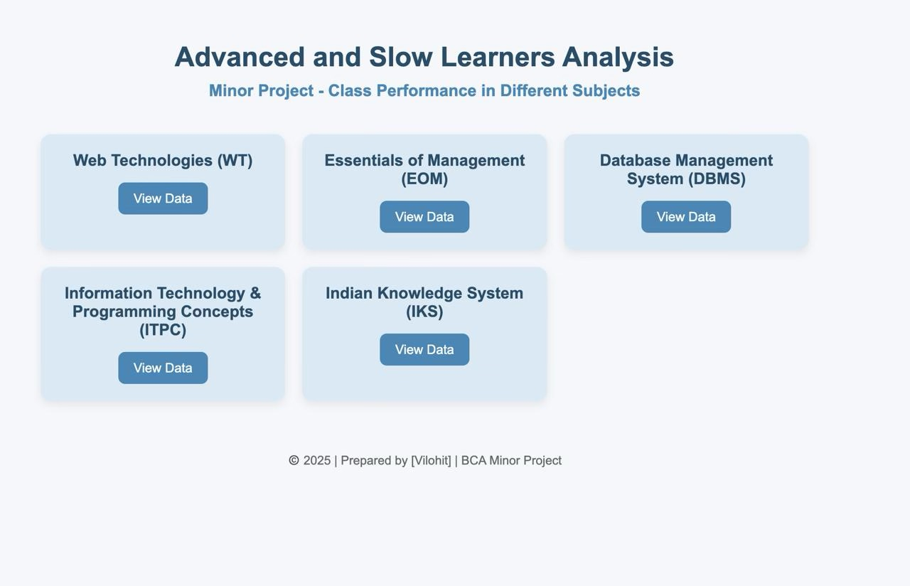
- Screen Design
- Report design
The report presents student performance by categorizing learners into Fast (Advanced), Average, and Slow based on marks. Each report section includes student details, obtained marks, and learning category. Tables, charts, and color-coded labels visually highlight performance differences. Summary statistics show total learners per group, class averages, and performance trends, helping teachers identify improvement areas, support needs, and high achievers for further enrichment.

Purpose and structure
The purpose of the report is to analyze student performance and classify them into Fast, Average, and Slow learners based on academic results. This helps teachers identify learning gaps and provide targeted support. The structure includes student details, marks, learner category, visual tables or charts, and summary statistics. It concludes with observations and actionable suggestions to improve learning outcomes and enhance overall academic performance.

Methodologies and Technologies
The report uses data collection through student assessment records and analyzes performance using percentage-based evaluation to categorize learners. Statistical comparison helps identify trends and learning gaps. Technologies used include HTML for report layout, CSS for styling, and JavaScript for dynamic data handling and interactivity. Charts or graphs may be generated using libraries like Chart.js to visually represent performance differences clearly and accurately.

Implementations Details
The system is implemented using HTML to structure student data, CSS for visual formatting, and JavaScript to process and categorize learners based on marks. Student scores are stored in arrays or JSON objects, and a function calculates percentages and assigns categories such as Slow, Average, or Fast. Dynamic tables and charts are generated to display results, enabling teachers to review performance quickly and efficiently.

System Testing

System testing ensures that learner classification and reporting work correctly. Test cases include checking correct percentage calculation, accurate categorization into Slow, Average, or Fast learners, and proper display of results in tables and charts. The interface is tested for usability, data validation, and error handling. Performance is verified with multiple student entries to ensure smooth operation without system crashes or incorrect results.

(a) Preparation of Test Data
Test data is prepared using sample student records containing names, roll numbers, and marks in different subjects. Data is created to represent various performance levels so that Slow, Average, and Fast learner categories can be tested accurately. Both valid and invalid data sets are included to check system behavior, such as missing values, incorrect formats, and extreme scores, ensuring reliable and complete system testing.

1. Objective Definition
The main objective of the system is to analyze student performance and categorize them into Slow, Average, and Fast learners based on assessment results. This classification helps teachers identify students who need additional support and those who require advanced learning opportunities. The system aims to present results clearly through structured reports, ensuring accurate evaluation, improved decision-making, and enhanced learning outcomes for all students.

2. User Profiles and Scenarios
1. Faculty/Teachers
Teachers use the system to upload class-wise CSV files containing student marks. They review total marks, averages, and grades to quickly evaluate performance. Visual charts help them identify weak subjects and plan additional support.
2. Students
Students can upload their own mark sheet CSV to instantly view their total score, average, overall grade, and strongest/weakest subjects for self-assessment.
3. Academic Administrators
Administrators upload combined departmental data to analyze performance trends, verify accuracy, and prepare academic reports based on system-generated visual analytics.

(b) Testing with Live Data
Testing with live data involves using actual student performance records from real assessments. This ensures the system functions correctly in real-time conditions. Live data helps verify accurate categorization, correct calculations, and proper display of results in tables and charts. It also checks system response to large datasets, user interactions, and real errors, ensuring practical reliability, usefulness, and readiness for classroom implementation.

- Data Migration and Integration
Data migration involves transferring existing student records from spreadsheets, manual registers, or previous systems into the new reporting system. Integration ensures smooth connectivity with other academic tools such as grading systems or attendance databases. During this process, data formats are standardized, duplicates removed, and errors corrected. The goal is to ensure accurate, secure, and seamless data flow for effective performance analysis and reporting.

2. User Feedback and Interactive Testing
User feedback and interactive testing involve allowing teachers and administrators to use the system and provide input on functionality, accuracy, and usability. They test features such as report generation, learner categorization, navigation, and visual clarity. Suggestions and issues reported by users are analyzed and implemented as improvements. This process ensures the system is user-friendly, practical, and aligned with real classroom needs.
3. Performance Monitoring and Scalability Testing
Performance monitoring evaluates how efficiently the system processes student data, generates reports, and responds to user actions. Scalability testing checks whether the system can handle increasing numbers of students, subjects, and datasets without slowing down or crashing. Load tests simulate high usage, while response time, memory usage, and processing speed are measured. This ensures the system remains reliable and effective as user demand grows.
4. Security and Compliance Validation
Security and compliance validation ensures that student data is protected and the system follows educational data regulations. Measures include encryption of stored and transmitted data, secure login access, controlled user permissions, and regular vulnerability checks. Compliance ensures that data handling follows institutional and legal standards. Proper auditing, backups, and secure storage protect confidential records, maintaining trust, integrity, and safe system operation.

5. Deployment Readiness and Continuous Improvement
Deployment readiness ensures the system is fully tested, stable, and configured for real-world use. All modules, reports, and data integrations are verified before rollout. After deployment, continuous improvement is maintained through regular updates, performance reviews, user feedback collection, and new feature enhancements. This ongoing development keeps the system efficient, user-friendly, and adaptable to changing academic needs and institutional requirements.

(c) Testing with Results
Testing with results involves comparing system-generated learner classifications, reports, and performance summaries with manually calculated outcomes to ensure accuracy. Sample student data is processed, and the results are verified for correct percentage calculation, category assignment, and proper display in charts and tables. Any mismatches or errors are documented and corrected. This ensures the system produces reliable, consistent, and meaningful academic performance reports.

Planning Test Cases
1. Identification of Test Scenarios
- Verify correct input of student details and marks.
- Test percentage calculation accuracy for all records.
- Check correct categorization into Slow, Average, and Fast learners.
- Validate generation of student performance reports.
- Ensure charts and graphs display data correctly.
- Test handling of missing or incomplete data inputs.
- Check behavior with incorrect or invalid data formats.
- Verify system performance with large student datasets.
- Test user navigation and interface usability.
- Ensure system security and proper access control across users.

2. Test Case Development
Test case development involves creating detailed test scripts to verify system functionality step by step. Each test case includes input data, execution steps, expected results, and actual outcomes. Test cases are designed for data entry, percentage calculation, learner categorization, report generation, error handling, chart display, and security validation. This ensures all system components function correctly and meet academic performance reporting requirements.

(d) Execution of Test Cases
Execution of test cases involves running each prepared test script to verify system behavior in real conditions. Inputs are entered, procedures followed, and results compared against expected outcomes. Any mismatches or errors are recorded for correction. Test execution covers data entry validation, performance calculations, learner categorization, report display, chart generation, error handling, and security checks to ensure the system operates accurately and reliably.

Testing Environment Setup
● Local Development Tools
Local development tools are software and utilities installed on a developer’s computer to build and test the system before deployment. These may include a code editor like VS Code, a local web server such as XAMPP or Node.js, browsers for testing, and version control tools like Git. They help developers write code, debug errors, preview reports, and ensure smooth functionality during development.

● Folder Structure
The system follows an organized folder structure for easy development and maintenance. The main directory includes folders such as /html for page layouts, /css for styling files, /js for interactive scripts, and /media for images or charts. Additional folders like /data or /assets store student records and resources. This structured hierarchy ensures clean organization, faster navigation, and efficient project management.

● Live Environment
A live environment is the real-time system setup where the application is deployed for actual use by teachers and administrators. It includes hosting on a secure web server, connected databases, and user access control. The system runs with real student data and operational workloads. Performance, reliability, security, and user experience are monitored to ensure smooth functioning in practical educational settings.

● Device Used
The system is accessed and tested using commonly available devices to ensure compatibility and smooth operation. These include desktop and laptop computers used by teachers for report generation, as well as tablets or smartphones for on-the-go access. Devices are equipped with modern browsers and stable internet connectivity. Testing on multiple screen sizes ensures the system is responsive, user-friendly, and accessible across different platforms.

● Browser Developer Tools
Browser Developer Tools are built-in utilities in modern web browsers like Chrome, Firefox, and Edge used to inspect and debug web applications. They allow developers to view HTML structure, modify CSS in real time, debug JavaScript, monitor performance, and analyze network activity. Console logs, breakpoints, responsiveness testing, and error tracking help ensure the system functions correctly and displays content accurately across devices.

2. Manual testing
Manual testing involves human testers interacting with the system to verify its functionality without using automated tools. Testers enter data, review system responses, and observe whether features like learner categorization, report generation, and chart display work correctly. They check for usability, interface clarity, and error handling. Manual testing helps identify issues related to real user behavior and ensures the system meets functional expectations.

Key Points of Manual Testing for This Code
- CSV Upload Verification – Tested with valid, invalid, empty, and corrupted CSV files.
- Data Validation – Checked handling of missing marks, non-numeric values, and incorrect headers.
- Grade Calculation Accuracy – Manually verified totals, averages, and assigned grades.
- Chart Rendering – Ensured bar charts and gauge widgets display correctly for all students.
- UI and Responsiveness – Checked layout on desktop and mobile devices.
- Error Handling – Tested alerts, invalid inputs, and file format warnings.
- Result Interpretation – Verified strongest/weakest subjects and standard deviation display.
- Navigation and Usability – Ensured smooth user flow and easy understanding of outputs.

3. Automated Testing
Automated testing uses scripts and tools to execute predefined test cases on the system without manual intervention. It validates functions such as data processing, learner categorization, report generation, and chart rendering. Automated tests increase efficiency, ensure consistency, and quickly identify regressions. Tools like Selenium or Jest can simulate user interactions, verify expected results, and provide detailed logs for faster debugging and quality assurance.Key Points of Automated Testing

- CSV Parsing Automation – Scripts verify correct reading of rows, headers, and values.
- Grade & Calculation Tests – Automated checks confirm totals, averages, grade logic, and subject-wise performance.
- Boundary Value Testing – Tests extreme inputs like max/min marks, empty values, or very large files.
- Chart Function Testing – Validates that chart libraries (like Chart.js) receive correct processed data.
- UI Behavior Testing – Automated tools check button clicks, file uploads, and output rendering.
- Regression Testing – Ensures updates in the code do not affect previously working features.
- Performance Testing – Measures response time when processing large datasets automatically.
- Error Handling Validation – Confirms system gracefully handles invalid or corrupted CSV files

(e) Analysis of Test Results
Analysis of test results involves reviewing the outcomes of manual and automated tests to determine system accuracy and reliability. Discrepancies between expected and actual results are identified, documented, and prioritized for correction. Metrics such as error rates, performance, and usability are evaluated. This process ensures the system correctly categorizes learners, generates accurate reports, and functions efficiently, guiding improvements and validation.

Key Points
- Categorizes students as Slow, Average, or Fast learners based on marks.
- Displays performance using tables, charts, and reports for clear analysis.
- Utilizes HTML, CSS, and JavaScript for interactive and responsive interface.
- Ensures accuracy and reliability through manual and automated testing.
- Implements security, scalability, and user feedback for improved system performance.

3. Continuous Improvement
- Iterative Testing and Feedback Incorporation:
Iterative testing involves repeatedly testing the system in cycles, incorporating user feedback after each round. Teachers and administrators review reports, learner categorizations, and interface usability, suggesting improvements. Developers update features, fix bugs, and enhance functionality based on feedback. This process ensures continuous refinement, increases system reliability, improves user satisfaction, and adapts the application to real-world classroom requirements effectively.

SYSTEM IMPLEMENTATION

System Requirements (Hardware/Software)

1. Hardware Requirements
The system requires basic hardware to run efficiently. Minimum requirements include a desktop or laptop with at least a dual-core processor, 4 GB RAM, and 500 MB free storage. A stable internet connection is needed for data access. Optional devices include tablets or smartphones for mobile access. Adequate display resolution ensures proper visualization of tables, charts, and reports.

2. Software Requirements
The system requires a modern operating system such as Windows, macOS, or Linux. A web browser like Chrome, Firefox, or Edge is necessary to access the application. Development tools include a code editor (e.g., VS Code), a local server environment (e.g., XAMPP, Node.js), and version control tools (e.g., Git). Optional libraries like Chart.js enhance data visualization for reports and charts.

3. Optional Tools
Optional tools enhance development, testing, and visualization of the system. These include libraries like Chart.js or D3.js for advanced charts, browser extensions for debugging, automated testing tools like Selenium or Jest, and collaborative platforms such as GitHub for version control. Code formatters, linters, and performance monitoring tools can also improve code quality, maintainability, and overall system efficiency..

4. Text Editor
A text editor is a software application used to write, edit, and manage the system’s code files. Common choices include Visual Studio Code, Sublime Text, or Atom. It provides syntax highlighting, code completion, and debugging support for HTML, CSS, and JavaScript. Using a text editor improves development efficiency, reduces errors, and enables organized project management.

5. Version Control
Version control is a system that tracks and manages changes to the project’s code and files over time. Tools like Git allow developers to maintain multiple versions, collaborate efficiently, and revert to previous states if needed. It ensures organized code management, facilitates teamwork, records change history, and helps prevent conflicts or loss of work during development and maintenance of the system.

6. Hosting Platform
A hosting platform provides the environment for deploying the Result Analysis System online or within an institution. Options include web servers like Apache, Nginx, or cloud services such as AWS, Azure, or Google Cloud. It ensures the system is accessible to users, supports data storage, manages server-side processes, maintains security, and provides reliable uptime for smooth real-time access and performance.

Documentation
Documentation provides detailed information about the system’s design, implementation, and usage. It includes user manuals, technical specifications, installation guides, and test reports. Proper documentation explains functionalities, workflows, folder structures, and data formats. It aids developers, testers, and users in understanding, maintaining, and operating the system effectively, ensuring smooth onboarding, troubleshooting, and future enhancements without dependency on original developers.

1. Hardware Requirements
The system requires basic hardware to run efficiently. Minimum requirements include a desktop or laptop with at least a dual-core processor, 4 GB RAM, and 500 MB free storage. A stable internet connection is needed for data access. Optional devices include tablets or smartphones for mobile access. Adequate display resolution ensures proper visualization of tables, charts, and reports.

2. Software Requirements
The system requires a modern operating system such as Windows, macOS, or Linux. A web browser like Chrome, Firefox, or Edge is needed to access the application. Development tools include a code editor (e.g., VS Code), a local server environment (e.g., XAMPP, Node.js), and version control software (e.g., Git). Optional libraries like Chart.js can be used for enhanced data visualization and reporting.

3. Optional Tools
Optional tools enhance development, testing, and user experience. These include libraries like Chart.js or D3.js for interactive charts, automated testing frameworks such as Selenium or Jest, and browser extensions for debugging. Collaboration platforms like GitHub or GitLab help manage code versions and teamwork. Code linters, formatters, and performance monitoring tools improve code quality, maintainability, and overall system efficiency.

4. Text Editor
Visual Studio Code (VS Code) is used for editing HTML, CSS, and JavaScript. Extensions like Prettier, Beautify, and Live Server make development easier and faster.

5. Version Control
Git is used to track all code changes, maintain history, and allow smooth collaboration. Repositories can be stored on GitHub for cloud backup and continuous updates.

6. Hosting Platform
The system can be deployed on:
GitHub Pages (free static hosting)
Vercel (fast and optimized for front-end apps)
These platforms allow users to access the Result Analysis System online and test it across devices.

7. Team Members
Vilohit- HTML
I contributed to this project by working on the HTML structure and correcting various errors and bugs. My responsibility was to organize the web pages, ensure the code was clean, and improve the layout so that all sections were clear and easy to navigate. I regularly checked the interface to make sure everything displayed properly.
Through careful debugging and continuous adjustments, I helped make the system more stable and user-friendly. My efforts focused on improving the overall appearance and smooth functioning of the project. These contributions reflect my dedication and support in the successful development of this work.

Vanshika- Backend Development Explanation
This project developed by Vanshika Kaushik analyses student performance and identifies Slow, Average, and Advanced Learners using dynamic backend processing. For the backend, I built a complete Flask-based server that manages file uploads, data extraction, and learner categorization. I used pandas to read Excel and CSV files and implemented automatic column detection so the system works even when file formats vary.
The backend processes each student’s marks, calculates totals, percentages, grades, and identifies strong and weak subjects. I also implemented class-level statistics such as average, median, highest, lowest, and standard deviation.
Based on the comparison with the class average, the backend assigns each student to an appropriate learner category.
Multiple API endpoints were created to deliver structured JSON data, including individual student reports, subject-wise insights, and overall performance summaries. This backend ensures accurate, real-time analysis for the frontend visualization.

Yuvraj- Css and JavaScript
This project, developed by Yuvraj Singh, analyzes student performance in multiple subjects using HTML, CSS, and JavaScript. The system displays learner categories such as Advance, Average, and Slow Learners by reading data from CSV files or API responses. JavaScript is used to fetch, parse, and display the data dynamically inside a modal window. CSS provides a clean, responsive layout with styled cards, tables, and statistics boxes. The project helps teachers easily understand class performance and identify learning levels. It is part of the Minor Project for academic evaluation.

System Design File/Data Design

HTML Files: Structured web pages for user interface elements.
CSS Files: Stylesheets for visual design and layout.
JavaScript Files: Client-side scripting for interactive features and user actions.
Media Files: Media assets for displaying album covers, artist images, and user avatars.
Other Files: Configuration files, documentation, and third-party libraries.

Database Storage
- This system does not use a traditional database. All student data is processed directly from the uploaded CSV file. The CSV acts as temporary data storage, enabling quick access to marks, subjects, and student names. After processing, results are stored in memory for generating charts, statistics, and grade summaries.

Implementation
Development Environment Setup
- The project is developed using a web-based environment with:
- Visual Studio Code
- Live Server extension
- Chrome Developer Tools
- HTML/CSS/JS files organized in separate folders
No backend server or database is required, reducing setup complexity.

Coding Standards
- Clean and readable code formatting
- Proper indentation and naming conventions
- Separation of concerns (HTML structure, CSS styling, JS logic)
- Comments added to explain logic for parsing CSV and generating charts
- Reusable functions for calculations (total, average, grade evaluation)

Version Control Workflow
- Git and GitHub are used throughout development.

Branching Strategy
- main branch → stable production-ready code
- feature branches → UI updates, new charts, CSV improvements
- bug-fix branches → resolving calculation errors, UI issues
- release branch → final code before deployment

Commit Practices & Pull Requests

- Frequent commits with meaningful messages
- Pull requests reviewed before merging
- No code merged into main without testing
- Merge conflicts resolved using GitHub’s tools

- Testing
Test Strategy
The test strategy defines the approach to validate the system’s functionality, performance, and reliability. It includes manual testing for usability and data accuracy, automated testing for repetitive tasks, and live data testing to simulate real scenarios. Key focus areas are learner categorization, report generation, chart visualization, error handling, and security compliance. Feedback loops ensure continuous improvement and issue resolution throughout the development lifecycle.

Performance Testing
Performance testing evaluates the system’s efficiency under various conditions, including large student datasets and simultaneous user access. It measures response times, data processing speed, report generation, and chart rendering. Load and stress tests identify bottlenecks, memory usage, and potential crashes. This ensures the system remains reliable, responsive, and scalable, providing smooth operation for teachers and administrators even during peak usage.

Security Testing
Security testing ensures that the system protects sensitive student data and complies with privacy regulations. It includes testing authentication, access control, data encryption, and secure data transmission. Vulnerabilities like SQL injection, cross-site scripting, and unauthorized access are checked. Regular security audits, backup verification, and controlled permissions help prevent data breaches, ensuring the system is safe, reliable, and trustworthy for academic use.

Deployment
Deployment Environment
The deployment environment is the setup where the Result Analysis System operates in real-time for users. It includes a web server (e.g., Apache, Nginx) or cloud platform (e.g., AWS, Azure), connected storage for CSV or database files, and compatible web browsers. The environment ensures secure access, proper performance, scalability, and availability for teachers and administrators in an academic setting.

Deployment Strategy
The deployment strategy outlines the steps to release the Result Analysis System for real-time use. It includes preparing the server environment, uploading application files, configuring databases, and testing connectivity. The strategy ensures smooth transition from development to live use, minimizes downtime, verifies functionality with sample data, and includes a rollback plan. Continuous monitoring and user feedback guide subsequent updates and improvements.

Configuration Management
Configuration management involves systematically organizing, tracking, and controlling all system components, including code, data files, libraries, and environment settings. Tools like Git maintain version history, enabling collaboration, rollback, and change tracking. Configuration management ensures consistency across development, testing, and deployment environments, reduces errors, supports reproducibility, and facilitates smooth updates, maintenance, and scalability of the Result Analysis System throughout its lifecycle.

User Guide
System Access
- Users open the website link in any modern browser.
No login or installation is required.

Features Overview
- Upload CSV file of student marks
- Automatic calculation of total, average, grade
- Identification of strongest and weakest subjects
- Chart generation for performance visualization
- Clean, responsive UI for easy navigation
Usage Instructions
- Open the web application.
- Click Upload CSV and select a marks file.
- Wait for data processing.
- View calculated grades, charts, summaries, and subject analysis.

Maintenance and Support
Monitoring and Maintenance Procedures
- Regular updates to UI and script logic
- Continuous testing with new sample datasets
- Checking for browser compatibility issues
- Monitoring feedback for improvement

Bug Tracking and Resolution
- Bugs are tracked using GitHub Issues:
- Each bug is assigned an ID, severity, and status
- Developers create a fix branch
- Bug is re-tested before closing the issue

Backup and Recovery
- Since the system uses static files:
- GitHub repository serves as full project backup
- Each version can be restored using Git history
- CSV files remain with the user (no server storage required)

SCOPE OF THE PROJECT

The scope of this Result Analysis System includes processing student marks from CSV files, calculating totals, averages, grades, and identifying performance strengths and weaknesses. It provides visual representation through charts and detailed summaries to help users quickly understand academic outcomes. The project covers front-end development using HTML, CSS, and JavaScript, ensuring smooth, fast, and client-side data processing without requiring a backend. It focuses on accuracy, usability, responsiveness, and secure data handling. Future scope includes adding downloadable reports, dashboards, advanced analytics, and multi-user support for broader academic use.

1. Functional Scope
The system allows users to upload CSV files, process student marks, calculate totals, averages, grades, and identify strong/weak subjects. It generates visual charts, displays performance summaries, and presents clear analytical results. All processing is done client-side without needing a backend server.

2. Technical Scope
The system is built using HTML for structure, CSS for design, and JavaScript for data processing and chart creation. It utilizes the FileReader API for reading CSVs and Chart.js for visualization. Runs on any browser with no installation or database requirement.

3. User Experience (UX) Scope
The interface ensures easy CSV upload, smooth navigation, and clear data visualization. Responsive design supports desktop and mobile. Results, charts, and summaries are displayed cleanly, helping users interpret student performance quickly and intuitively.

4. Security and Compliance Scope
CSV validation prevents incorrect or malicious files. No sensitive data is stored on servers—processing occurs locally in the browser, ensuring privacy. Input sanitization protects against script injection. The system aligns with basic data protection principles.

5. Scalability and Performance Scope
The system supports large CSV datasets with hundreds of students. Client-side calculations and chart rendering ensure fast performance. Lightweight code and optimized loops maintain speed even with complex data.

6. Feature Enhancement Scope
Future improvements may include downloadable reports, additional chart types, machine-learning-based predictions, login-based dashboards, subject-wise comparison tools, and automated grade boundaries. The modular codebase allows easy feature expansion.

7. Content Management Scope
Static content such as instructions, labels, themes, and UI text can be updated easily through HTML/CSS. CSV templates and example files can be managed without affecting system functionality. All result content is dynamically generated from uploaded data.

8. Analytics and Insights Scope
The system provides performance analytics including averages, grade distribution, strongest subjects, weakest areas, and standard deviation. Charts offer visual insights for quick understanding. Additional analytics like trends or comparisons can be integrated later.

9. Community and Interactive Scope
The current version is single-user, but future plans may include teacher-student portals, shared dashboards, result sharing, interactive comparison tools, or feedback forms. Collaborative features can be built using APIs or cloud integration later.

BIBLIOGRAPHY

· MDN Web Docs – JavaScript Documentation
Mozilla Developer Network. JavaScript Guide, FileReader API, Array Methods, and DOM Manipulation.
https://developer.mozilla.org
· W3Schools – HTML, CSS, and JavaScript Tutorials
References for front-end structure, styling, and scripting basics used in the project.
https://www.w3schools.com
· Chart.js Official Documentation
Guide for implementing charts and visualizations used in result analysis.
https://www.chartjs.org
· CSV Data Format Specification
Used for understanding CSV structure and parsing rules.
https://tools.ietf.org/html/rfc4180
· Stack Overflow Community Discussions
Troubleshooting and optimizing CSV parsing, chart rendering, and UI issues.
https://stackoverflow.com
· GitHub Documentation
Version control practices and project deployment guidance.
https://docs.github.com

1. Tutorials:
· W3Schools HTML Tutorials were used to understand webpage structure, form elements, buttons, and table formatting required for displaying processed student results.
· W3Schools CSS Tutorials helped in styling the layout, improving readability, adding spacing, alignment, colors, and making the interface more user-friendly.
· W3Schools JavaScript Tutorials provided guidance on variables, arrays, functions, loops, and DOM manipulation, which were essential for processing CSV data and updating the interface dynamically.
· MDN Web Docs tutorials on FileReader API helped implement CSV file upload functionality, parsing text, and handling file errors safely.
· MDN tutorials on JavaScript Array Methods contributed to writing clean logic for averaging marks, calculating grades, and identifying strong/weak subjects.
· Chart.js Official Tutorials and Documentation guided the implementation of bar charts, configuration of labels, datasets, axes, and rendering visual performance analytics.
· YouTube tutorials on Responsive Web Design supported making the interface mobile-friendly and improving the overall user experience.
· YouTube tutorials on JavaScript Projects inspired logic structure, data flow, and dynamic content generation.
· Developer blogs (GeeksforGeeks, Medium) provided practical examples for error handling, sorting data, and improving processing efficiency for large CSV files.
· Git and GitHub tutorials helped in version control, pushing code, managing branches, and deploying the project on a hosting platform.
· Debugging tutorials using Chrome Developer Tools assisted in identifying script errors, optimizing loops, and improving the rendering performance of charts.
· Online tutorials on static site deployment were used to host the project on GitHub Pages or Netlify for live testing and public accessibility.

2. Deployment Platforms:
The project can be deployed on static hosting services like GitHub Pages, Netlify, or Vercel, which provide fast, reliable, and free hosting for HTML, CSS, and JavaScript files. These platforms enable quick deployment, easy updates, and smooth browser-based access for all users.

